# How to launch an UWP from another UWP

## Introduction

This sample demonstrates how to launch an UWP app from another UWP app.

After the launched app named “CSReceiveUri” has been installed, run the launcher app named “CSAppLauncher”,

Click any button in the main page of CSAppLauncher, the launched app will be opened in launcher app and the info will be displayed by the parameter from launcher app.

Actually, default app of the protocol will be used to launch an app. Take http for instance , its default app is browser.

## Sample prerequisites

To open and run this sample, ensure the following requisites has been reached:

1. Microsoft Windows 10(10.0.14393) or above.
2. Microsoft Visual Studio 2015 Update3 or later version(s).
3. Microsoft Visual Studio installed UWP developer component.

## Building the sample

1. Open the sample solution **“CSLaunchUWPInAnOtherUWP.sln”** using Visual Studio.
2. In Solution Explorer, right click project “**CSReceiveUri**” and choose **Deploy**.

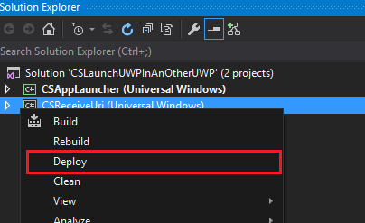

1. In Solution Explorer, right click project “**CSAppLauncher**” and select **Set as StartUp Project**.

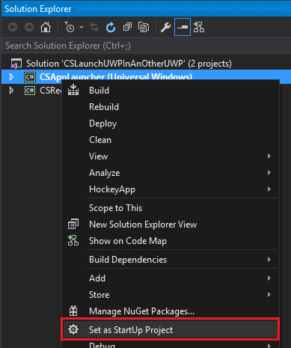

## Running the sample

* Use Visual studio to open the sample solution, then press **F5 Key** or select **Debug -> Start Debugging** from the menu.
* When the app is running, you can see this:

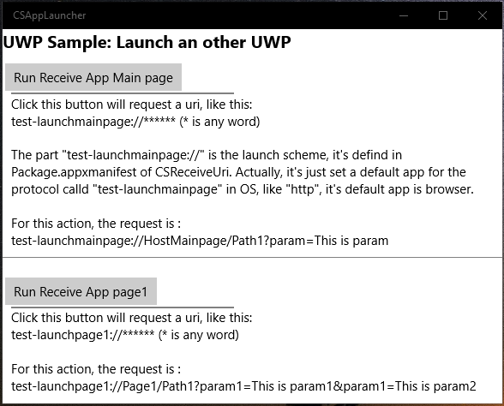

* Click the “**Run Receive app Main page**“ button, the CSReceiveUri app will be run with main page.

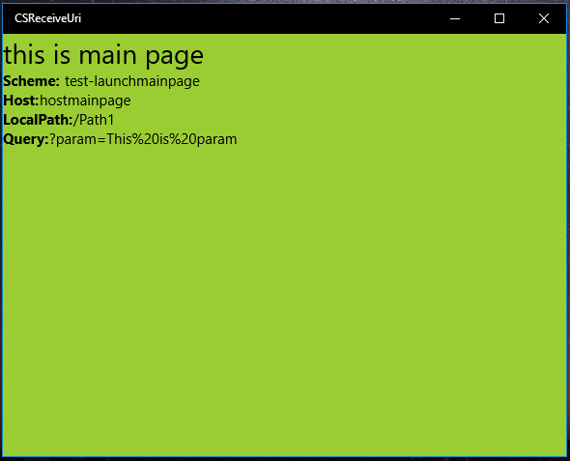

* Click the second “**Run Receive App page1**” button, the app CSReceiveUri will be run with page1.

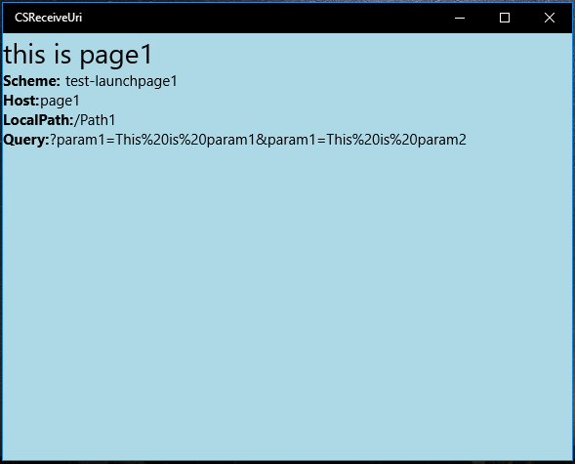

## Using the code

* In project CSAppLauncher, The Launch Code is:

private async void RunMainPage_Click(object sender, RoutedEventArgs e)

{

await LaunchAppAsync("test-launchmainpage://HostMainpage/Path1?param=This is param");

}

private async void RunPage1_Click(object sender, RoutedEventArgs e)

{

await LaunchAppAsync("test-launchpage1://Page1/Path1?param1=This is param1&param1=This is param2");

}

private async Task LaunchAppAsync(string uriStr)

{

Uri uri = new Uri(uriStr);

var promptOptions = new Windows.System.LauncherOptions();

promptOptions.TreatAsUntrusted = false;

bool isSuccess = await Windows.System.Launcher.LaunchUriAsync(uri, promptOptions);

if (!isSuccess)

{

string msg = "Launch failed";

await new MessageDialog(msg).ShowAsync();

}

}

* In the project CSReceiveUri, The config in **Package.appxmanifest** is:

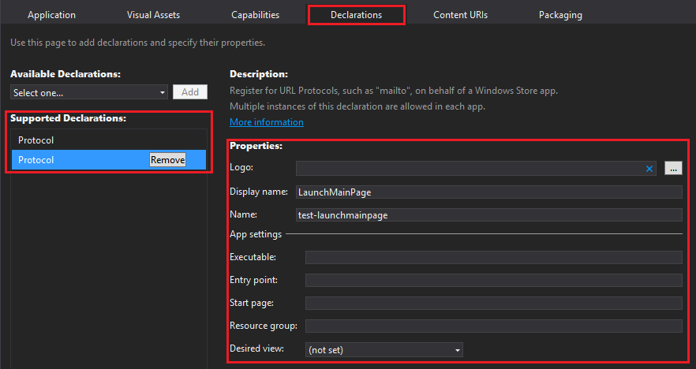

The XML format is:

<Package>

<Applications>

<Application Id="App" Executable="$targetnametoken$.exe" EntryPoint="CSReceiveUri.App">

<Extensions>

<uap:Extension Category="windows.protocol">

<uap:Protocol Name="test-launchpage1">

<uap:DisplayName>LaunchPage1</uap:DisplayName>

</uap:Protocol>

</uap:Extension>

<uap:Extension Category="windows.protocol">

<uap:Protocol Name="test-launchmainpage">

<uap:DisplayName>LaunchMainPage</uap:DisplayName>

</uap:Protocol>

</uap:Extension>

</Extensions>

</Application>

</Applications>

</Package>

* There is an event handler called OnActivated in file app.cs. Here is the relevant code:

protected override void OnActivated(IActivatedEventArgs args)

{

if (args.Kind == ActivationKind.Protocol)

{

Frame rootFrame = Window.Current.Content as Frame;

if (rootFrame == null)

{

rootFrame = new Frame();

Window.Current.Content = rootFrame;

rootFrame.NavigationFailed += OnNavigationFailed;

}

var protocolEventArgs = args as ProtocolActivatedEventArgs;

switch (protocolEventArgs.Uri.Scheme)

{

case "test-launchmainpage":

rootFrame.Navigate(typeof(MainPage), protocolEventArgs.Uri);

break;

case "test-launchpage1":

rootFrame.Navigate(typeof(Page1), protocolEventArgs.Uri);

break;

default:

rootFrame.Navigate(typeof(MainPage), protocolEventArgs.Uri);

break;

}

Window.Current.Activate();

}

}

## More information

Using cross-app communication to enable apps to work together (10 by 10):

<https://blogs.windows.com/buildingapps/2015/09/22/using-cross-app-communication-to-make-apps-work-together-10-by-10/>

Handle URI activation

<https://msdn.microsoft.com/en-us/windows/uwp/launch-resume/handle-uri-activation>